SLB Tool, available for Beta test from CSFS IT staff now!

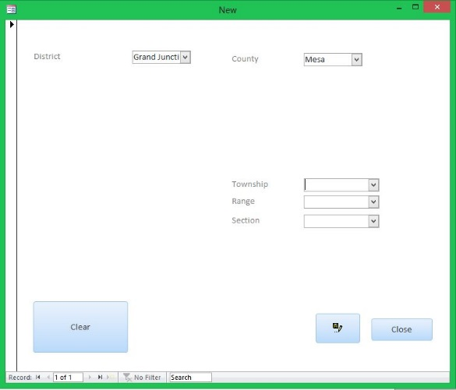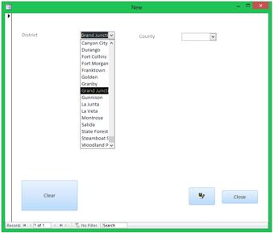

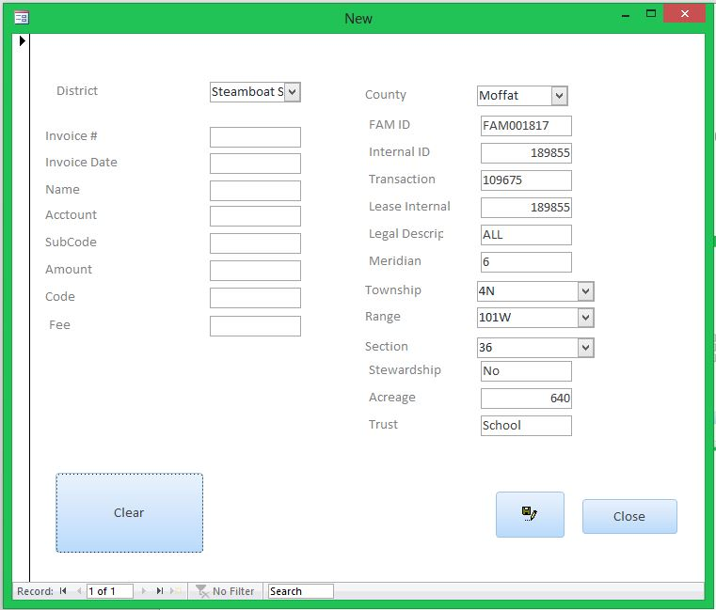

The name says it all. The new SLB TOOL is the latest software solution for the SLB data entry agency needs.

Previously as an agency we had to manually enter into a spreadsheet, information from an invoice. Import this spreadsheet into a program to output desired reports.

With the all new solution developed in house, we have streamlined this process. The data is entered into a program. The program aides with data entry. Additionally, from this system we can easily generate a variety of reports for relevant information to SLB.

The basics of this application are as follows: As a user you will be able to:

Select what “District”

Based on the chosen District the county list will pre-populate with counties available for the chosen “District”.

Based on the chosen County:

Township, Range, & Section are pre-populated to match the narrowed “District” & “County” choices.